**Name: Jaganmohan Chandramohan**

**ID: 1000772027**

**Type of Notation**: Chen’s Notation Entity Relationship Diagram

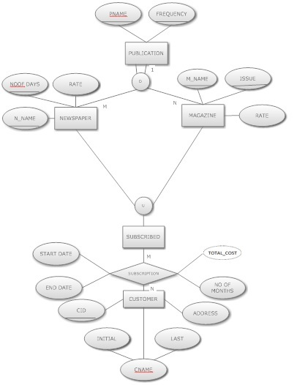

**Entity types**

**Customer** is an entity type that holds the details of the customer.

**CId** - Id for customer (Primary key)

**Initial –** Initial name of customer

**Last –** Last name of customer

**Address –** Address of the customer

**Publication** is a super class entity which is been inherited by Magazine and Newspapers.

**P_Name** –Name of the Publication (Unique Key)

**Frequency** – Frequnecy of Publication (Composite primary key)

**Magazine** is specialization of Publication, which hold all the details of magazine

**M_name** – Name of Magazine (Composite Primary Key)

**Issue –** No of Issues (Composite Primary Key)

**Rate –** Rate per Issue

**Newspaper** is specialization of Publication, which hold all the details of magazine

**N_name** – Name of Magazine (Composite Primary Key)

**No of Days –** No of Days (Composite Primary Key)

**Rate –** Rate per Issue

**Subscribed** is a union of the Newspaper and Magazine

**Relation – Relation**

**Subscription** is a M:N relation between subscribed and customer with attributes:

**Start_Date –** Start Date of Subscription

**End_Date -** End Date of Subscription

**No of Months** – Number of issues of Newspaper

**Total_cost** – Total cost of the issues subscribed by a customer.(Derived attribute from issues, rate, start_date)

**Missing attributes:**

* Each Newspaper has a name and id under each publication name
* Each Magazine under each frequency has a name and id under each publication name
* Each subscription has a subscription id for each customer